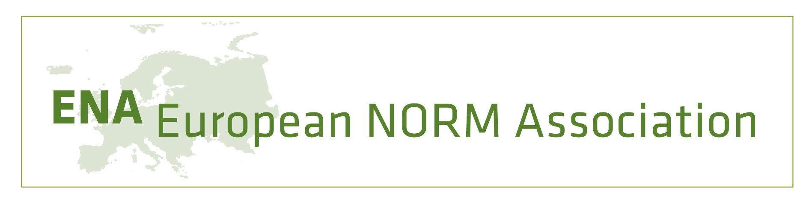
Membership application form for the European NORM Association (ENA)

Applicant’s details:
Membership for (please tick as appropriate) | Legal person |  | Natural person
Name:
In case of legal person member, name of contact person:
Address:
Email:
Other contact details (voluntary), e.g., telephone, fax:

If membership is applied for by a legal person, please tick appropriate type of organisation:
Education and research |  | Professional associations
Authority |  | Corporations
Private organizations |  | Partnerships
If organisation: number of employees

Type of membership applied for (please tick as appropriate):
Ordinary
Corporate
Associated
Student

ENA member supporting this application:
Name:
(Please attach supporting letter to this application.)

I confirm that I have received a copy of the Statutes of ENA, a copy of the current membership fee schedule and a copy of the Code of Ethics of ENA.
I declare that I will adhere to the Code of Ethics.

Date
Place
Signature of applicant
Please submit to: | European NORM Association – ENA  c/o Stéphane Pepin, Treasurer  Rue du Tulipier, 32 – 1190 Brussels, Belgium  Email: stephane.pepin@fanc.fgov.be  Cc: christian.ahrens@nuclear-cc.de (ENA Secretary)

